3.1 Sensor-Driven Reactive Behaviors
One of the simplest and most effective ways for a robot to interact with its environment is through reactive behavior. In reactive navigation, the robot makes decisions directly from sensor inputs without first building a detailed map of its surroundings. When new information is detected, the robot immediately adjusts its actions. This creates a fast feedback cycle that allows the robot to respond to changing environments in real time.
Reactive behaviors are commonly used when a robot must avoid collisions, follow walls, track objects, or stop before hitting an obstacle. Because the robot does not perform extensive calculations before acting, reactive systems typically have very low latency and can react quickly to sudden changes.
A basic reactive control loop looks like this:
Sensor Input → Decision Rule → Motor Command → Movement
↑ ↓
└──────── Updated Sensor Data ────┘
For example:
IF obstacle distance < 10 cm
THEN turn right
The robot continuously evaluates this rule while driving.

VEX AIM Robot Example: Obstacle Avoidance
Suppose a VEX AIM robot is driving through a classroom.

Sensor Input
The AIM Distance Sensor detects a desk 8 cm in front of the robot.
Distance = 8 cm

Decision Rule
The control program contains:
IF distance < 10 cm
THEN turn right

Action
The robot slows its left wheel and increases its right wheel speed, causing the robot to turn away from the obstacle.

Result
The robot avoids the desk without needing a map of the room.
This entire process may occur several times per second.

VEX AIM Robot Example: Object Following
Reactive behaviors can also be used to follow a target.

Sensor Input
The Distance Sensor detects a game piece located 50 cm away.

Decision Rule
IF object is far away
THEN move forward

IF object is too close
THEN stop

Action
The AIM robot continuously adjusts its speed while approaching the object.
The robot reacts directly to sensor measurements rather than calculating a complete route.

Real-World Example 1: Robotic Vacuum Cleaners
Most robotic vacuum cleaners use reactive behaviors.

Sensor Input
- Bump sensors
- Distance sensors
- Cliff sensors

Decision Rules
IF obstacle detected
THEN turn

IF stairs detected
THEN reverse

Action
The vacuum immediately changes direction.
Reactive navigation allows the vacuum to operate effectively even though it may not have a complete map of the home.

Real-World Example 2: Automatic Emergency Braking Systems
Modern vehicles often contain collision-avoidance systems.

Sensor Input
- Radar
- Cameras
- LIDAR

Decision Rule
IF collision risk is high
THEN apply brakes

Action
The vehicle automatically slows down or stops.
This is a reactive behavior because the action occurs immediately in response to sensor data.

Advantages of Reactive Navigation
Reactive systems are:
- Fast
- Simple to program
- Reliable in changing environments
- Computationally efficient
Because of these advantages, reactive behaviors are often the first autonomous behaviors programmed on VEX robots.

Limitations of Reactive Navigation
Reactive systems also have limitations:
- No long-term planning
- No memory of previous obstacles
- Can become trapped in corners or loops
- May not find the shortest path to a goal
For this reason, advanced robots often combine reactive behaviors with path planning and mapping algorithms.

Multiple-Choice Question 1
A VEX AIM robot is driving forward when its Distance Sensor detects a wall 5 cm away. The robot immediately turns left to avoid a collision. Which robotics concept is being demonstrated?
A. Inverse Kinematics
B. Reactive Navigation ✅
C. Odometry
D. Path Planning
Correct Answer: B
Explanation: The robot is reacting directly to sensor input without first building a map or calculating a complex route.

Multiple-Choice Question 2
Which of the following is the best example of a reactive behavior?
A. A warehouse robot calculating the shortest route across a building.
B. A self-driving car creating a city-wide navigation plan.
C. A robotic vacuum turning immediately after hitting a chair leg. ✅
D. A robot storing a map of an environment for future use.
Correct Answer: C
Explanation: Reactive behaviors are immediate responses to sensor inputs. Turning after detecting an obstacle is a classic example of reactive navigation.

CodeLens Activity: VEX AIM Obstacle Avoidance
Read the following pseudocode and determine what the robot will do.
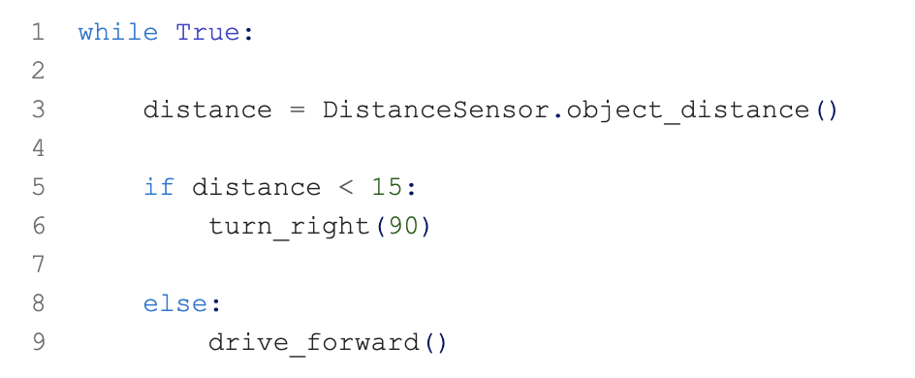

while True:

distance = DistanceSensor.object_distance()

if distance < 15:
turn_right(90)

else:
drive_forward()

Question
If the robot detects an obstacle 10 cm away, what action will occur?
- A. Continue driving forward
- B. Stop permanently
- C. Turn right 90 degrees ✅
- D. Drive backward
Answer: C
Because the measured distance is less than 15 cm, the robot executes the obstacle-avoidance behavior and turns right.

